DATABASE SYSTEMS PROJECT REPORT 2023



Project Idea: Online Restaurant Management System

Project Title: Fork&Knife Finesse

Project Members:
Fizza Rashid 21K-3390
Tania Saleh 21K-4695

Purpose of Our Project
The purpose of this system implementation is to provide a user-friendly interface where customers receive the best services. The unique feature of our restaurant is we allow users to direct with restaurant owners/managers and share their valuable personal information along with their honest feedback.
Moreover, we have taken care of our customer’s precious time by providing the facility of an advanced table booking system.

Proposed Interfaces
Our project is composed of two interfaces:

1) Restaurant Admins/managers: They are the primary audience. They will use the system to streamline operations, manage customers, manage menu details, billing status etc. and make informed decisions to improve the overall efficiency and profitability of the restaurant.

2) Customers: Our website has customer facing features, like online
ordering, reservation management, loyalty programs and many more.

TESTING & SAMPLE OUTPUTS

SQL Queries
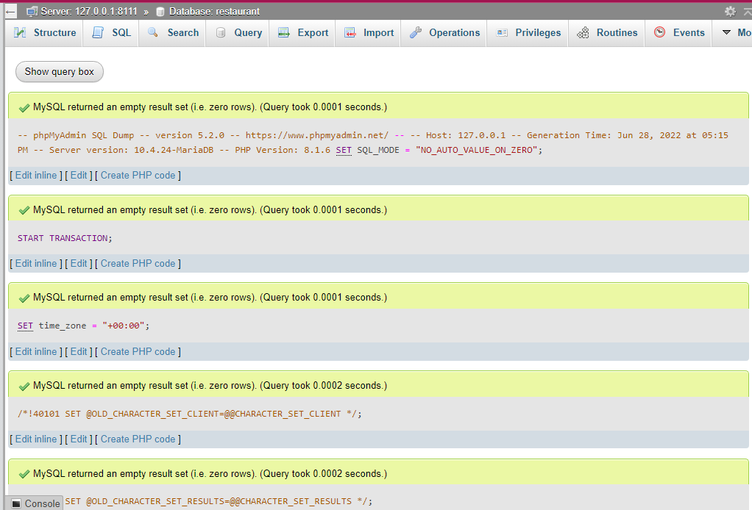

Database Tables
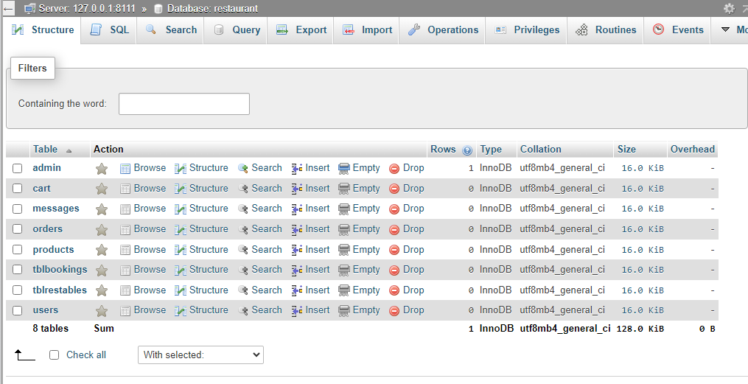

Main Screens (User’s Interface)

- Home Screen
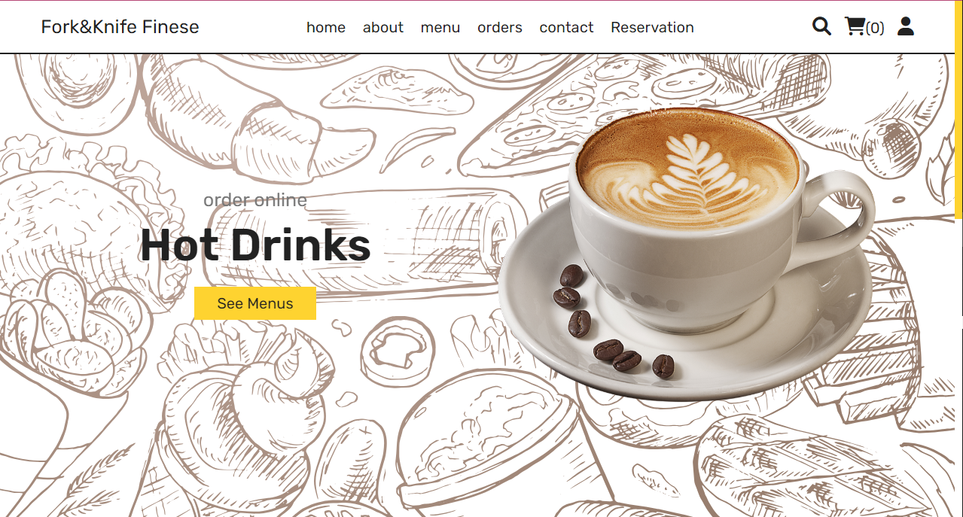

- About Us Screen
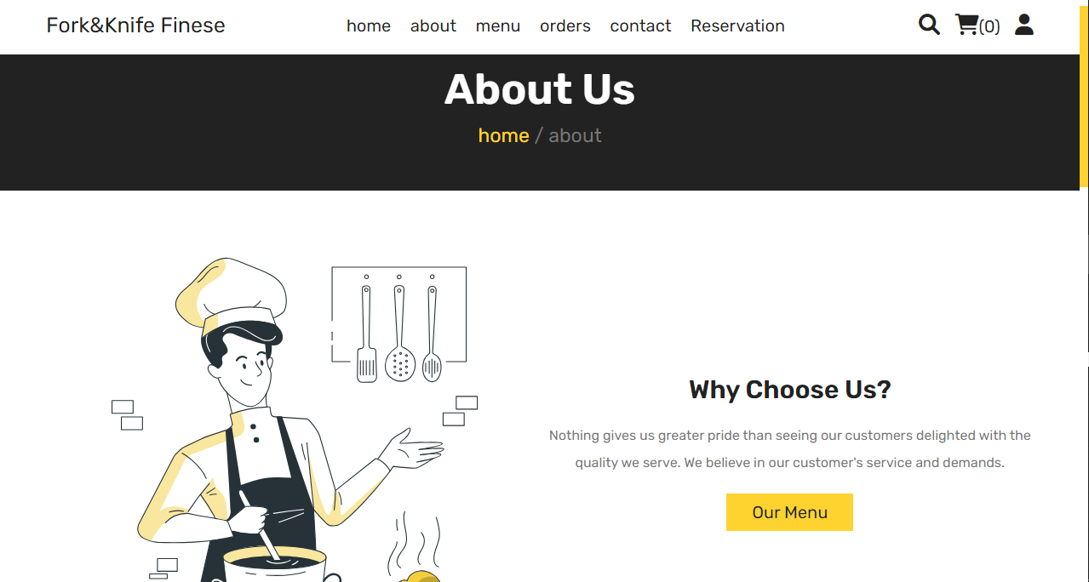

- Menu Screen
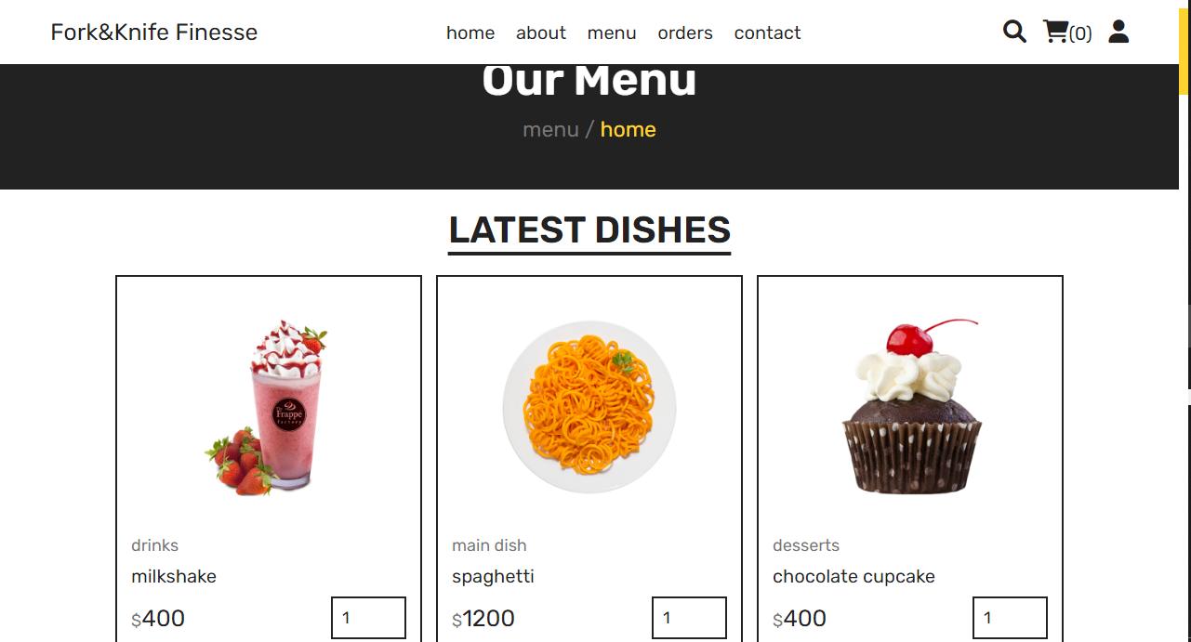

- Orders Screen
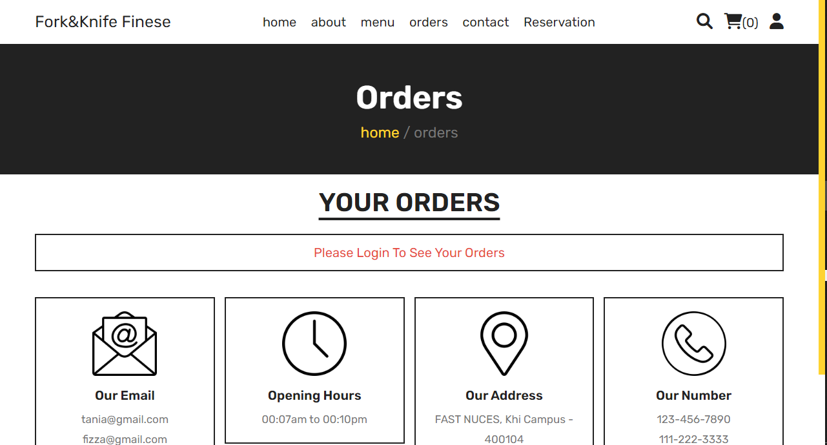

- Contact Us Screen
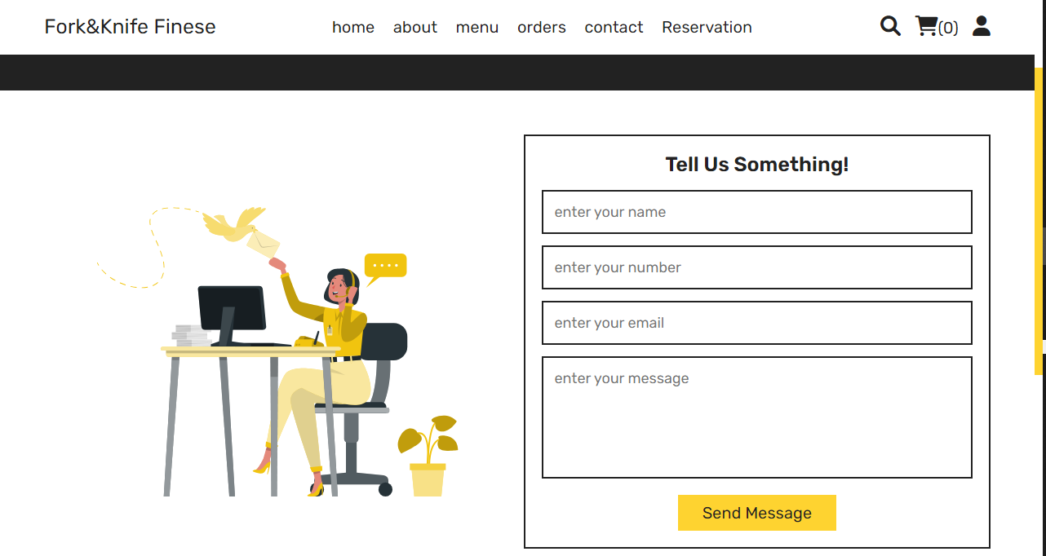

- Table Reservation Screen
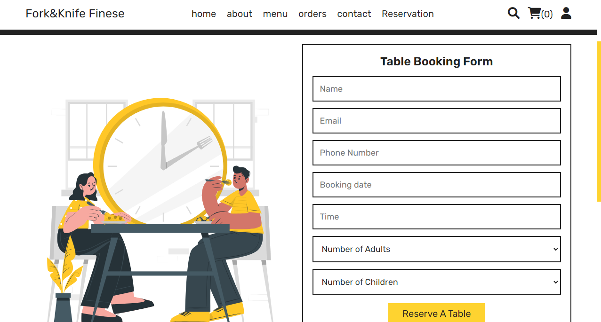

—---------------------------------------------------------------------------------------------------------------------------

Header:

Footer:


Main Screens (Admin’s Interface)

- Admin’s Dashboard
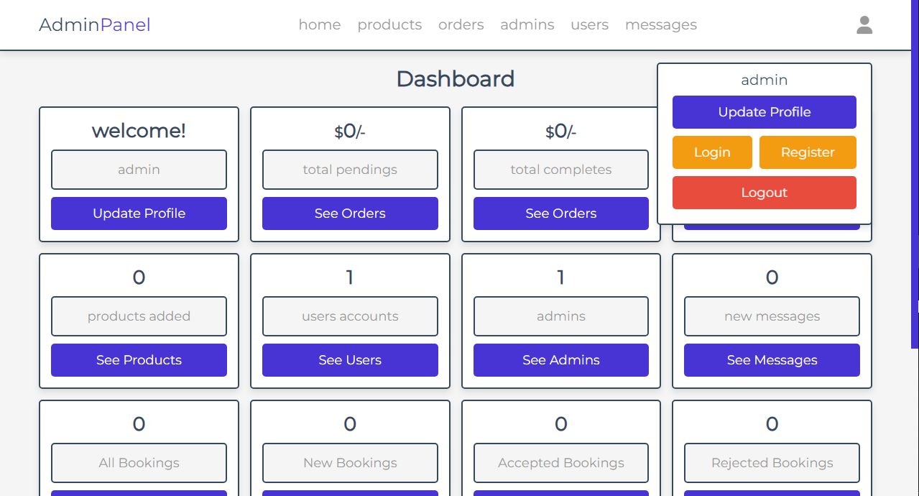

- Products Management
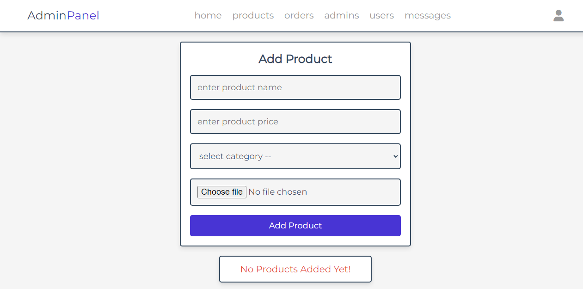

- Orders Management


- Admin’s Entry Management
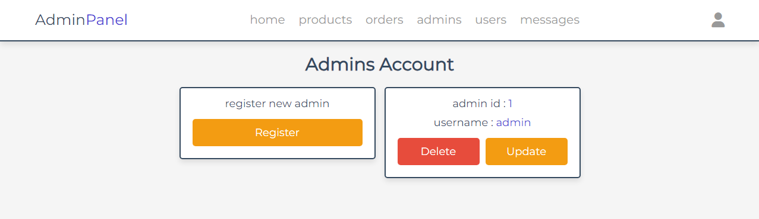

- User’s Details Management


- Feedbacks Management


- Table Reservation Management
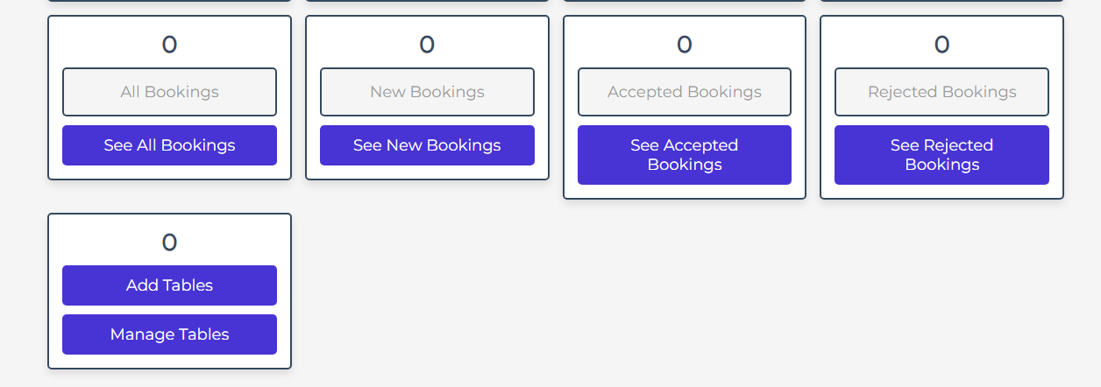

Entity Relationship Diagram

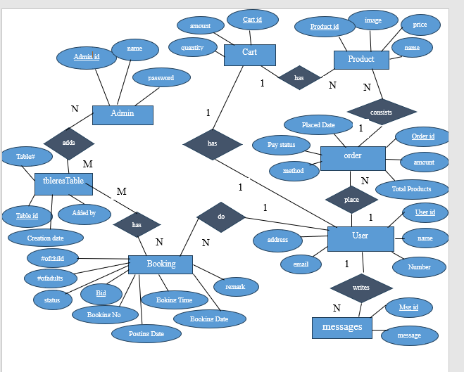

Languages/frameworks Use:
PHP, JS , HTML, CSS

For Database:
MySQL

Conclusion:

The restaurant management systems reflect a diverse range of projects addressing various aspects of restaurant operations, customer engagement, and technological advancements. The field continues to evolve, driven by innovations in software, hardware, and data analytics, with the goal of enhancing the dining experience, optimizing efficiency, and increasing the profitability of restaurants.

—---------------------------------------END-—--------------------------------------

